**[Email Combo for Monday, Sept. 11]**

**[Subject: We Need Everyone in the Game!]**

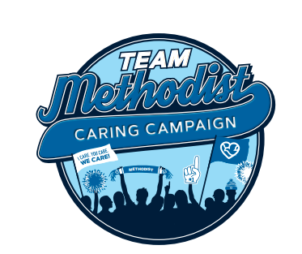

**Team,**

We’re in this together. Caring Campaign is our chance to help co-workers in need and send a powerful message to our communities: **We not only work at Methodist, we support it.**

Every dollar counts and moves us toward our goal of 100% participation. **We need everyone in the game!**

**Lisa** wanted to send a personal message – she knows firsthand the difference the Caring Coworkers Fund can make in the lives of others.

**[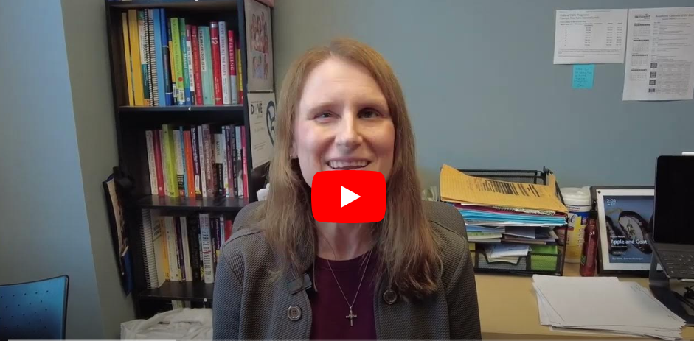](https://www.youtube.com/watch?v=CIy440IVyzg)**

**Thank you, Lisa!**

**If you’ve already made your pledge, thank you!** You’re automatically entered into weekly, $50 gift card drawings through October 11. The first ten winners are posted at [Methodist Hospital Foundation](https://methodisthospitalfoundation.org/caringcampaign2024).

**If you haven’t made your gift yet**, either turn in your paper pledge form or go online to our [Methodist Intranet](https://nmhs.service-now.com/esc?id=sc_cat_item&table=sc_cat_item&sys_id=ef68e3eb1b57651085ccc80f034bcbdc).

**Caring Campaign wraps up at the end of the month.** Let’s keep our momentum going!

[Signature]

**For more information about Caring Campaign, more videos and a fun photo gallery, visit** [Methodist Hospital Foundation](https://methodisthospitalfoundation.org/caringcampaign2024).