**[Email for Monday, Sept. 4]**

**[Subject: Caring Campaign Is Underway!]**

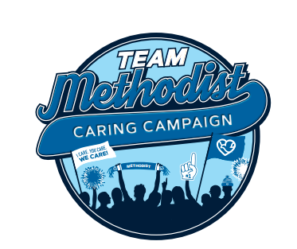**Team,**

Once a year we ask you to participate in **Caring Campaign –** and you always come through. Employee giving at Methodist is more than twice the national average!

We are one team, lending a hand to our coworkers, patients and communities. Because of your participation, we have a strong employee assistance program called [**Caring Coworkers Fund**](https://methodisthospitalfoundation.org/caringcoworkers) (formerly Family Crisis Connection).

Your support ensures it’s always available for co-workers like Kristyduring times of need. She wanted to personally say thank you.

**[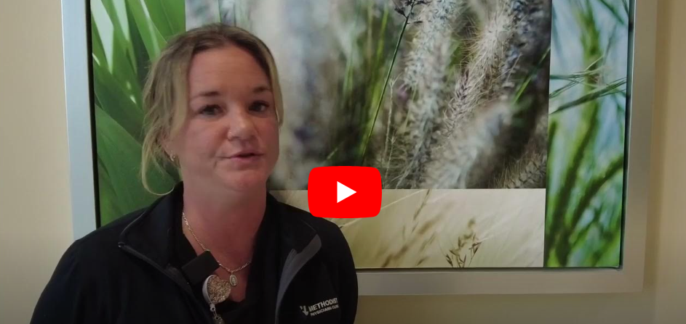](https://www.youtube.com/watch?v=p3ARyhFevz4)**

**Thank you, Kristy!**

Your gift, no matter the size, makes a difference. It’s really the participation – what we do collectively – that counts.

**Let’s hit 100% as a department!** Either turn in your paper pledge form or go online to our [Methodist Intranet](https://nmhs.service-now.com/esc?id=sc_cat_item&table=sc_cat_item&sys_id=ef68e3eb1b57651085ccc80f034bcbdc).

The sooner you participate, the more chances you have to win. The Foundation is giving away ten $50 gift cards each week, starting **Wednesday, Sept. 6.**

Please let me know if you have any questions.

[Signature]

**For more information about Caring Campaign, more videos and a fun photo gallery, visit** [Methodist Hospital Foundation](https://methodisthospitalfoundation.org/caringcampaign2024).